

*IdentityIQ Accelerator Pack External Integration (REST/SCIM)*

Table of Contents

1. Overview 3

2. SCIM/REST Apis 3

3. Input Variables 3

4. Output Varaibles 4

5. Audit 4

6. Preventive Policy Violation 4

7. Multiple Account Selection Form 5

8. Provisioning Policy Form Completion 5

9. Advanced Analytics 5

10. Report 5

**Document Revision History**

|  |  |  |  |  |
| --- | --- | --- | --- | --- |
| **Version** | **Date** | **Status** | **Author** | **Summary of Changes** |
| Version 1 | 3/2/18 |  | Rohit Gupta |  |

## Overview

This document outlines the external integration of Accelerator Pack with either REST or SCIM Api

## SCIM/REST Apis

Accelerator Pack integerates with SCIM/REST **Workflow Invocation Api** to handle external requests.

## Input Variables

|  |  |
| --- | --- |
| Variable Name (* Required) | Description |
| identityName* | Name of the identity being processed (required) |
| launcher* | Name of the requestor |
| ticketId | Ticketing System Ticket Id |
| ticketManagementApplication | Name of the application or source in the IdentityIQ instance that handles ticket requests |
| flow* | External |
| requestType* | EXTERNAL FEATURE  In case approvals are required. This can be configured in “Custom-ApprovalFrameWorkMappings” |
| workflowName | Workflow-FrameWork-Wrapper |
| extPolicyScheme | “None” or “Interactive”.  Default: Policy Scheme defined in custom artifact “Custom-Framework-Common-Settings” will be used |
| extSendRequestorNotifications | Submission, Completion, Provisioning Policy Form, Account Selection Form, and Preventive Policy Violation Form Notifications  Either “True” or “False”  Default: Accelerator Pack will send out notifications to Human Identity |
| plan or planMap* | ProvisioningPlan (Required) |
| foregroundProvisioning | “True” or “False”  Default:False |
| trace | “True” or “False”  Default:False |

## Output Varaibles

|  |  |
| --- | --- |
| Variable Name | Description |
| identityRequestId | Identity Request Id |
| spExtAttrs | Example  spExtAttrs={requester=DEMO1, requestType=EXTERNAL FEATURE, identityRequestId=0000000109, source=LCM, flow=External, launcher=DEMO1}, identityRequestId=0000000109}, errors=null, status=null} |
| requestID | Task Result Id |

## Audit

Provisioning of External requests will be audited using Accelerator Pack Audit Event “roadWebservicesRequest”.

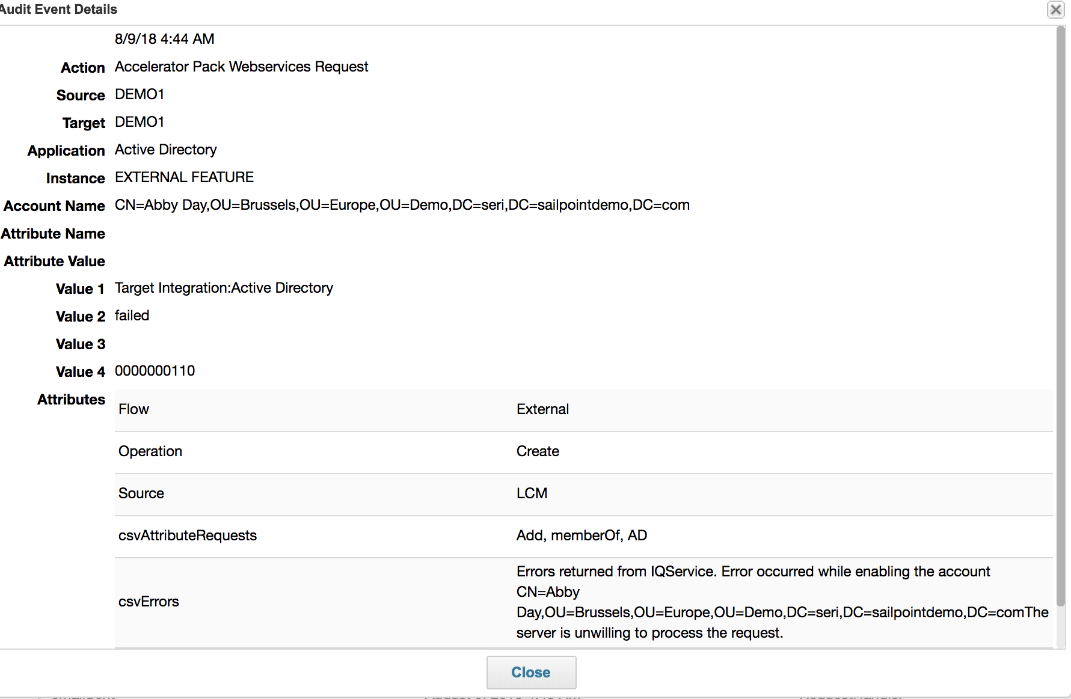

## Preventive Policy Violation

An email will be sent out to the launcher to finish the workitem

## Multiple Account Selection Form

An email will be sent out to the launcher to finish the workitem

## Provisioning Policy Form Completion

An email will be sent out to the launcher to finish the workitem

## Advanced Analytics

Request Type can be used to filter out “External” requests

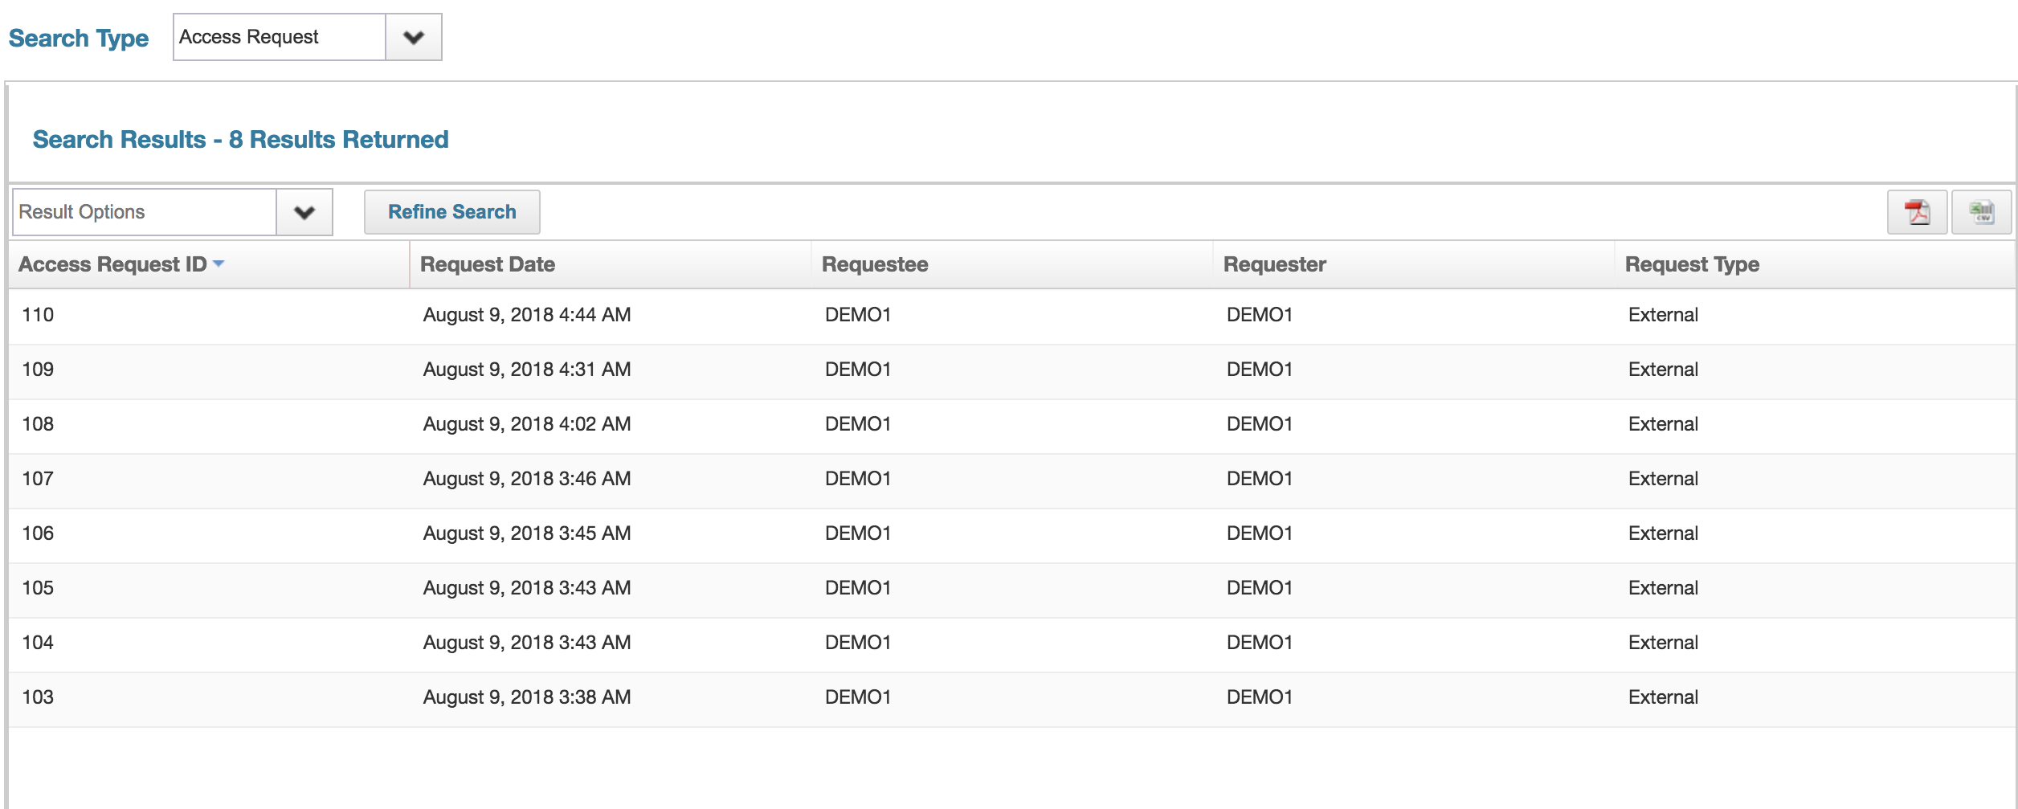

## Report

“Access Request Status Report Extended” can be used to display External Access Requests